The centre is located 1.25 miles North East of the centre of North Walsham, Norfolk.
OS Map 133, Ref 294 315.
PostCode NR28 ORB.
From The South
Entering North Walsham on the B1150 from Norwich, pass under the rail bridge. At the traffic lights turn left. At the next set of traffic lights go straight over. Follow this road for about 2 miles (passing the local industrial area to your left), then take the second right (opposite the Quaker meeting house). Follow this country lane for approx 0.75 miles, and take the first turning on the left down an un-signed lane. The Centre is at the bottom of this lane.
From The West/North
Enter North Walsham on the A149 from Cromer, pass under the rail bridge. At the traffic lights turn left. Follow this road for about 2 miles (passing the local industrial area to your left), then take the second right (opposite the Quaker meeting house). Follow this country lane for approx 0.75 miles, and take the first turning on the left down an un-signed lane. The Centre is at the bottom of this lane.
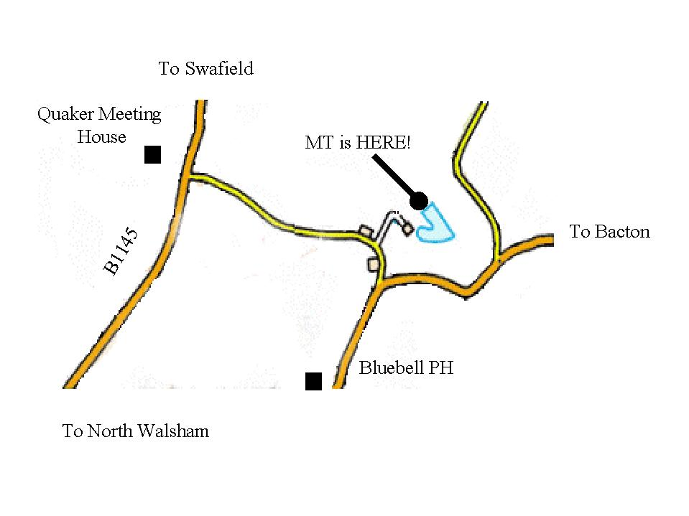

The centre is located 1.25 miles North East of the centre of North Walsham, Norfolk.
OS Map 133, Ref 294 315.
PostCode NR28 ORB.
From The South
Entering North Walsham on the B1150 from Norwich, pass under the rail bridge. At the traffic lights turn left. At the next set of traffic lights go straight over. Follow this road for about 2 miles (passing the local industrial area to your left), then take the second right (opposite the Quaker meeting house). Follow this country lane for approx 0.75 miles, and take the first turning on the left down an un-signed lane. The Centre is at the bottom of this lane.
From The West/North
Enter North Walsham on the A149 from Cromer, pass under the rail bridge. At the traffic lights turn left. Follow this road for about 2 miles (passing the local industrial area to your left), then take the second right (opposite the Quaker meeting house). Follow this country lane for approx 0.75 miles, and take the first turning on the left down an un-signed lane. The Centre is at the bottom of this lane.

